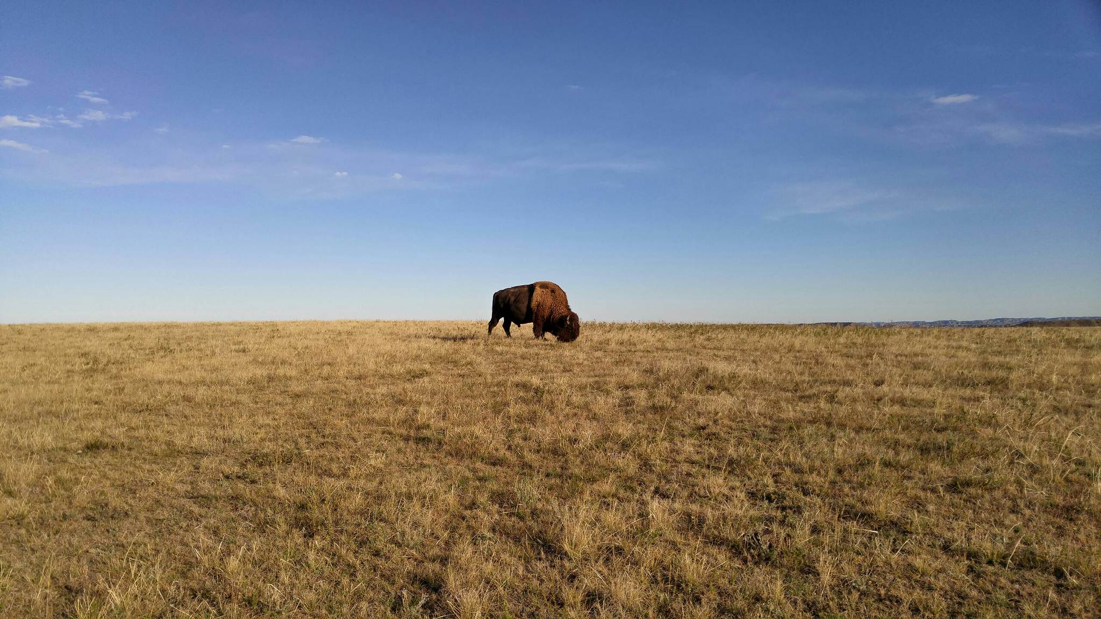

State of North Dakota

Mitigation Plan for the

Volkswagen Environmental

Mitigation Trust Agreement

1st Revision

North Dakota Department of Environmental Quality Division of Air Quality

August 2021

[cid:image001.png@01D4FE62.89CA3E90](http://www.health.nd.gov/)

**Table of Contents Page**

Background……………………………………………………………………………………………………………….3

Available Funding and Eligible Applicants………………………………………………………………….3

Mitigation Plan Overview………………………………………………………………………………………….4

Goals for the Use of the Funds………………………………………………………………………………….5

Eligible Mitigation Actions…………………………………………………………………………………………5

1. Class 8 Local Freight Trucks and Port Drayage Trucks………………………………...6

2. Class 4-8 School Bus, Shuttle Bus, or Transit Bus………………………………………..7

3. Freight Switchers………………………………………………………………………………………..8

4. Ferries/Tugs……………………………………………………………………………………………….10

5. Ocean Going Vessels Shorepower………………………………………………………………10

6. Class 4-7 Local Freight Trucks…………………………………………………………………….10

7. Airport Ground Support Equipment…………………………………………………………..11

8. Forklifts and Port Cargo Handling Equipment…………………………………………….12

9. Light Duty Zero Emission Vehicle Supply Equipment………………………………….13

10. Diesel Emission Reduction Act (DERA) Option………………………………………….14

Eligible Mitigation Action Administrative Expenditures……………………………………………..15

Project Selection and Prioritization……………………………………………………………………………15

Measuring Emission Reductions and Environmental Benefits……………………………………18

Additional Beneficiary Responsibilities………………………………………………………………………18

Public Information and Input…………………………………………………………………………………….20

Definitions…………………………………………………………………………………………………………………21

**Background**

In October 2016, a Partial Consent Decree was finalized between the United States Department of Justice and the Volkswagen Corporation (VW) along with its subsidiaries, regarding the installation and use of emission testing defeat devices in approximately 500,000 of their diesel-powered vehicles. These vehicles were sold and operated in the United States beginning in 2009. The use of these devices resulted in increased air emissions of nitrogen oxide (NOx), which negatively impacted air quality and violated the Clean Air Act.

VW agreed to pay $14.7 billion to settle allegations of the installation and use of the emission testing defeat devices in its vehicles. The settlement is divided into three separate parts. Ten billion dollars of the settlement will be used to buy back or repair the impacted diesel vehicles owned by consumers. The second part of the settlement requires VW to create a National Zero Emission Vehicle (ZEV) investment plan and spend $2 billion on ZEV infrastructure and programs that increase public awareness of zero emission vehicles. The third part of the settlement, and the focus of this document, is the environmental mitigation trust (or Trust). The environmental mitigation trust is contained in Appendix D of the Partial Consent Decree. The environmental mitigation trust has been established to mitigate the environmental damages caused by the use of the defeat devices in VW’s vehicles. This part of the settlement required VW to place $2.7 billion into a trust fund which will be used to fund a variety of diesel emission reduction projects across the country. All States, Tribes, Puerto Rico, and the District of Columbia have been allocated a portion of the Trust, based on the number of affected vehicles in each respective jurisdiction. The Trust accounts for each state will be administered by Wilmington Trust, a third-party asset management entity.

This update to North Dakota’s Volkswagen Mitigation Plan is being provided in accordance with the Trust requirements. Additional information is included below and provides details regarding the minor revisions to North Dakota’s initial plan dated August 2019.

**Available Funding and Eligible Applicants**

North Dakota’s allocation of the VW environmental mitigation trust fund is $8,125,000. As the designated “Beneficiary” for the State of North Dakota, the North Dakota Department of Environmental Quality (NDDEQ) was allowed to request up to one-third of the State’s total allocation during the first year, or up to two-thirds of the allocation during the first two years after the Trust was funded. The following amounts were contracted to awarded entities for eligible projects during the first two years of North Dakota’s VW program.

First Year: $2,517,250 Second Year: $3,371,103

A new VW spending authority amount for the NDDEQ’s program of $4,485,118 was established during the 2021 North Dakota Legislative Session. The spending authority value is the legislatively authorized amount an agency in North Dakota can spend on budget items or programs. This new spending authority will cover the next two years of the State’s VW program (2021-2022).

In subsequent years of the program, North Dakota will continue to award funding for eligible projects as Trust funds remain, while continuing to work within the confines of any adjustments to the agency’s spending authority as prescribed by the North Dakota Legislature.

Government and non-Government entities are eligible to apply for funding to implement NOx reduction projects as outlined in this document.

**Mitigation Plan Overview**

To fulfill the requirements of Appendix D of the Partial Consent Decree, on behalf of the State of North Dakota, the NDDEQ has developed this mitigation plan to provide an outline of how the mitigation trust funds will be utilized in the State. Although the mitigation plan is non-binding and may be revised upon proper communication with the fund’s Trustee, as the designated Beneficiary for the State of North Dakota, the NDDEQ provides this mitigation plan as a general guideline as to how allocated funds will be spent. According to the Partial Consent Decree, the mitigation plan should contain the following:

1. The Beneficiary’s overall goal for the use of the funds.

2. The categories of eligible mitigation actions the Beneficiary anticipates will be appropriate to achieve the stated goals and the preliminary assessment of the percentages of funds anticipated to be used for each type of eligible mitigation action.

3. A description of how the Beneficiary will consider the potential beneficial impact of the selected eligible mitigation action on air quality in areas that bear a disproportionate share of the air pollution burden within its jurisdiction.

4. A general description of the expected ranges of emission benefits the Beneficiary estimates would be realized by implementation of the eligible mitigation actions identified in the mitigation plan.

5. An explanation of the process by which the Beneficiary shall seek and consider public input on its mitigation plan.

The mitigation plan only needs to provide the level of detail that is reasonably ascertainable at the time of submission. The mitigation plan may be adjusted at the discretion of the Beneficiary, and any updates shall be provided to the Trustee as necessary.

**Goals for the Use of the Funds**

The primary goal of the environmental mitigation trust is to reduce NOx emissions. In addition, Beneficiaries may consider how the mitigation trust funds could provide additional benefits including health, economic development, fuel security, greenhouse gas emission reductions, energy, renewable portfolio standards, and benefits to vulnerable populations.

NOx compounds are a group of several related compounds that include nitrogen oxide (NO) and nitrogen dioxide (NO2). NO and NO2 are the most prevalent forms of NOx released by combustion processes, including from diesel engines. Ground-level ozone, a major component of smog, is created when NOx reacts with carbon monoxide (CO) and volatile organic compounds (VOCs) in sunlight. Although smog is not a major air quality issue in North Dakota, it is a significant problem in other parts of the United States.

Health effects of ozone can include asthma and other respiratory system issues, allergies, and premature death. Particulate matter (PM) emissions are another component of diesel emissions that may also contribute to negative health impacts. Cardiovascular and respiratory effects, as well as premature deaths, may also be attributed to PM emissions.

In addition to the above-mentioned health risks, NOx also significantly contributes to acid rain. Acid rain can lead to the damage of crops, forests, waterways, and property.

It is anticipated that by meeting the goals of this mitigation plan by completing eligible mitigation actions that reduce NOx emissions in North Dakota, additional benefits will be achieved. Additional pollutant reductions will take place and the environment in general will likely benefit as well.

**Eligible Mitigation Actions**

Beneficiaries shall spend funds from the environmental mitigation trust on projects that fit into ten eligible mitigation action categories. The goal of each eligible category is to reduce NOx emissions.

The categories focus primarily on repowering or replacing medium and heavy-duty, diesel- powered equipment, and the installation of light duty, zero emission vehicle supply equipment. The NDDEQ anticipates funding projects in the following eligible mitigation actions as indicated below.

|  |  |  |
| --- | --- | --- |
| **Category** | **Eligible Mitigation Action** | **Estimated Funding\*** |
| 1 | Class 8 Eligible Large Trucks | 25-75% |
| 2 | Class 4-8 Eligible Buses | 10-50% |
| 3 | Freight Switchers | 0-10% |
| 4 | Ferries/Tugs | 0% |
| 5 | Ocean Going Vessels Shorepower | 0% |
| 6 | Class 4-7 Eligible Medium Trucks | 0-25% |
| 7 | Airport Ground Support Equipment | 0-10% |
| 8 | Forklifts and Port Cargo Handling Equipment | 0-10% |
| 9 | Light Duty Zero Emission Vehicle Supply Equipment | 10-15% |
| 10 | Diesel Emission Reduction Act (DERA) Option | 0% |

*Percentage of the total state trust allocation.

Allowable project reimbursements per the settlement are as follows below. The final reimbursement rates are provided in application materials issued by the NDDEQ. The NDDEQ requires all applicants to provide some cost-share for projects in categories 1, 2, 3, 6, 7 and 8.

**1. Class 8 Local Freight Trucks and Port Drayage Trucks (Eligible Large Trucks)** - repower or replacement of vehicles 33,001 pounds and larger.

* Eligible large trucks include 1992-2009 engine model year Class 8 vehicles.
* Examples include, but may not be limited to cement mixers, dump trucks, fire trucks, and large (tour type) buses.
* The replaced large truck must be scrapped.
* Replaced engines must be scrapped.
* Long haul trucks are not eligible under this mitigation action.
* Eligible large trucks may be repowered or replaced with any new diesel, alternate fuel, or all electric vehicle, with an engine model year in which the mitigation action occurs or one engine model year prior.

Reimbursement percentages for projects that can be funded through the Trust for Category 1: Class 8 Local Freight Trucks and Port Drayage Trucks:

For non-Government owned eligible Class 8 Local Freight Trucks, Beneficiaries may only draw funds from the Trust in the amount of:

1. Up to 40% of the cost of a repower with a new diesel or alternate fueled (e.g., CNG, propane, Hybrid) engine, including the costs of installation of such engine.

2. Up to 25% of the cost of a new diesel or alternate fueled (e.g., CNG, propane, Hybrid) vehicle.

3. Up to 75% of the cost of a repower with a new all-electric engine, including the costs of installation of such engine, and charging infrastructure associated with the new all-Electric engine.

4. Up to 75% of the cost of a new all-electric vehicle, including charging infrastructure associated with the new all-electric vehicle.

Non-Government owned eligible drayage trucks, Beneficiaries may only draw funds from the Trust in the amount of:

1. Up to 40% of the cost of a repower with a new diesel or alternate fueled (e.g., CNG, propane, Hybrid) engine, including the costs of installation of such engine.

2. Up to 50% of the cost of a new diesel or alternate fueled (e.g., CNG, propane, Hybrid) vehicle.

3. Up to 75% of the cost of a repower with a new all-electric engine, including the costs of installation of such engine, and charging infrastructure associated with the new all-electric engine.

4. Up to 75% of the cost of a new all-electric vehicle, including charging infrastructure associated with the new all-electric vehicle.

Government owned eligible Class 8 Large Trucks, Beneficiaries may draw funds from the Trust in the amount of:

1. Up to 100% of the cost of a repower with a new diesel or alternate fueled (e.g., CNG, propane, Hybrid) engine, including the costs of installation of such engine.

2. Up to 100% of the cost of a new diesel or alternate fueled (e.g., CNG, propane, Hybrid) vehicle.

3. Up to 100% of the cost of a repower with a new all-electric engine, including the costs of installation of such engine, and charging infrastructure associated with the new all-electric engine.

4. Up to 100% of the cost of a new all-electric vehicle, including charging infrastructure associated with the new all-electric vehicle.

**2. Class 4-8 School Bus, Shuttle Bus, or Transit Bus (Eligible Buses)** – repower or replacement of Class 4-8 school, shuttle, or transit buses 14,001 pounds and larger.

* Eligible buses include those with engine model year 2009 and older.
* The replaced bus must be scrapped.
* Replaced engines must be scrapped.
* Eligible buses may be repowered or replaced with any new diesel or alternate fuel, or all electric bus, with an engine model year in which the mitigation action occurs or one engine model year prior.

Reimbursement percentages for projects that can be funded through the Trust for Category 2: Class 4-8 School Bus, Shuttle Bus, or Transit Bus:

Non-Government owned buses, Beneficiaries may draw funds from the Trust in the amount of:

1. Up to 40% of the cost of a repower with a new diesel or alternate fueled (e.g., CNG, propane, Hybrid) engine, including the costs of installation of such engine.

2. Up to 25% of the cost of a new diesel or alternate fueled (e.g., CNG, propane, Hybrid) vehicle.

3. Up to 75% of the cost of a repower with a new all-electric engine, including the costs of installation of such engine, and charging infrastructure associated with the new all-electric engine.

4. Up to 75% of the cost of a new all-electric vehicle, including charging infrastructure associated with the new all-electric vehicle.

For Government owned eligible buses, and privately-owned school buses under contract with a public school district, Beneficiaries may draw funds from the Trust in the amount of:

1. Up to 100% of the cost of a repower with a new diesel or alternate fueled (e.g., CNG, propane, Hybrid) engine, including the costs of installation of such engine.

2. Up to 100% of the cost of a new diesel or alternate fueled (e.g., CNG, propane, Hybrid) vehicle.

3. Up to 100% of the cost of a repower with a new all-electric engine, including the costs of installation of such engine, and charging infrastructure associated with the new all-electric engine.

4. Up to 100% of the cost of a new all-electric vehicle, including charging infrastructure associated with the new all-electric vehicle.

**3. Freight Switchers** – repower or replacement of pre-Tier 4 switcher locomotives that operate 1,000 or more hours per year.

* The replaced freight switcher must be scrapped.
* Replaced engines must be scrapped.
* Eligible Freight Switchers may be repowered with any new diesel, alternate fueled or all-electric engine(s) (including generator sets) or may be replaced with any new diesel or alternate fueled or all-electric (including generator sets) freight switcher, that is certified to meet the applicable EPA emissions standards (or other more stringent equivalent State standard) as published in the CFR for the engine model year in which the eligible freight switcher mitigation action occurs.

Reimbursement percentages for projects that can be funded through the Trust for Category 3: Freight Switchers.

For Non-Government owned freight switchers, Beneficiaries may draw funds from the Trust in the amount of:

1. Up to 40% of the cost of a repower with a new diesel or alternate fueled (e.g., CNG, propane, Hybrid) engine(s) or generator sets, including the costs of installation of such engine(s).

2. Up to 25% of the cost of a new diesel or alternate fueled (e.g., CNG, propane, Hybrid) freight switcher.

3. Up to 75% of the cost of a repower with a new all-electric engine(s), including the costs of installation of such engine(s), and charging infrastructure associated with the new all-electric engine(s).

4. Up to 75% of the cost of a new all-electric freight switcher, including charging infrastructure associated with the new all-electric freight switcher.

For Government owned eligible freight switchers, Beneficiaries may draw funds from the Trust in the amount of:

1. Up to 100% of the cost of a repower with a new diesel or alternate fueled (e.g., CNG, propane, Hybrid) engine(s) or generator sets, including the costs of installation of such engine(s).

2. Up to 100% of the cost of a new diesel or alternate fueled (e.g., CNG,

propane, Hybrid) freight switcher.

3. Up to 100% of the cost of a repower with a new all-electric engine(s), including

the costs of installation of such engine(s), and charging infrastructure associated with

the new all-electric engine(s).

4. Up to 100% of the cost of a new all-electric freight switcher, including charging

infrastructure associated with the new all-electric freight switcher.

**4. Ferries/Tugs** – eligible ferries and tugs include unregulated Tier 1 or Tier 2 marine engines.

It is anticipated that no mitigation action projects will likely be completed in this category in North Dakota. Few, if any, ferries or tugs are thought to exist in North Dakota. In addition, during the public comment periods in which the public provided comments or ideas on drafting North Dakota’s initial environmental mitigation trust plan, no comments were received pertaining to these types of projects. Should the NDDEQ become aware of such projects, a revision to the mitigation plan could be submitted to the Trustee.

**5. Ocean Going Vessels Shorepower** – eligible marine shorepower includes systems that enable a compatible vessel’s main and auxiliary engines to remain off while the vessel is at berth.

It is anticipated that no mitigation action projects will be completed in this category in North Dakota. Due to North Dakota’s geographic location, there are no ocean-going vessels in the State.

**6. Class 4-7 Local Freight Trucks (Medium Trucks)** - repower or replacement of vehicles 14,001 to 33,000 pounds.

* Eligible medium trucks include 1992-2009 engine model year Class 4-7 vehicles.
* Examples include, but may not be limited to, delivery/walk in vehicles, bucket trucks, fuel delivery trucks, garbage trucks, medium semi tractors, and city transit buses.
* The replaced medium truck must be scrapped.
* Replaced engines must be scrapped.
* Eligible large trucks may be repowered or replaced with any new diesel or alternate fuel, or all electric vehicle, with an engine model year in which the mitigation action occurs or one engine model year prior.

Reimbursement percentages for projects that can be funded through the Trust for Category 6: Class 4-7 Local Freight Trucks (Medium Trucks).

For non-Government owned eligible medium trucks, Beneficiaries may draw funds from the Trust in the amount of:

1. Up to 40% of the cost of a repower with a new diesel or alternate fueled (e.g., CNG, propane, Hybrid) engine, including the costs of installation of such engine.

2. Up to 25% of the cost of a new diesel or alternate fueled (e.g., CNG, propane, Hybrid) vehicle.

3. Up to 75% of the cost of a repower with a new all-electric engine, including the costs of installation of such engine, and charging infrastructure associated with the new all-electric engine.

4. Up to 75% of the cost of a new all-electric vehicle, including charging infrastructure associated with the new all-electric vehicle.

For Government owned eligible medium trucks, Beneficiaries may draw funds from the Trust in the amount of:

1. Up to 100% of the cost of a repower with a new diesel or alternate fueled (e.g., CNG, propane, Hybrid) engine, including the costs of installation of such engine.

2. Up to 100% of the cost of a new diesel or alternate fueled (e.g., CNG, propane, Hybrid) vehicle.

3. Up to 100% of the cost of a repower with a new all-electric engine, including the costs of installation of such engine, and charging infrastructure associated with the new all-electric engine.

4. Up to 100% of the cost of a new all-electric vehicle, including charging infrastructure associated with the new all-electric vehicle.

**7. Airport Ground Support Equipment** – repower or replacement of Tier 0, Tier 1, or Tier 2 diesel powered airport ground support equipment, and uncertified or certified to 3 g/bhp-hr or higher emissions, spark ignition engine powered airport ground support equipment.

* The replaced airport ground support equipment must be scrapped.
* Eligible airport ground support equipment may be repowered with an all-electric engine or may be replaced with the same airport ground support equipment in an all-electric form.

Reimbursement percentages for projects that can be funded through the Trust for Category 7: Airport Ground Support Equipment.

For non-Government owned eligible airport ground support equipment, Beneficiaries may only draw funds from the Trust in the amount of:

1. Up to 75% of the cost of a repower with a new all-electric engine, including costs of installation of such engine, and charging infrastructure associated with such new all-electric engine.

2. Up to 75% of the cost of a new all-electric airport ground support equipment, including charging infrastructure associated with such new all-electric airport ground support equipment.

For Government owned eligible airport ground support equipment, Beneficiaries may draw funds from the Trust in the amount of:

1. Up to 100% of the cost of a repower with a new all-electric engine, including costs of installation of such engine, and charging infrastructure associated with such new all-electric engine.

2. Up to 100% of the cost of a new all-electric airport ground support equipment, including charging infrastructure associated with such new all-electric airport ground support equipment.

**8. Forklifts and Port Cargo Handling Equipment** – eligible forklifts include forklifts with greater than 8,000 pounds of lift capacity.

* The replaced forklifts and port cargo handling equipment must be scrapped.
* Eligible forklifts and port cargo handling equipment may be repowered with an all-electric engine or may be replaced with the same equipment in an all-electric form.

Reimbursement percentages for projects that can be funded through the Trust for Category 9: Forklifts and Port Cargo Handling Equipment.

For non-Government owned eligible forklifts and port cargo handling equipment, Beneficiaries may draw funds from the Trust in the amount of:

1. Up to 75% of the cost of a repower with a new all-electric engine, including costs of installation of such engine, and charging infrastructure associated with such new all-electric engine.

2. Up to 75% of the cost of a new all-electric forklift or port cargo handling equipment, including charging infrastructure associated with such new all-electric forklift or port cargo handling equipment.

For Government owned eligible forklifts and port cargo handling equipment, Beneficiaries may draw funds from the Trust in the amount of:

1. Up to 100% of the cost of a repower with a new all-electric engine, including costs of installation of such engine, and charging infrastructure associated with such new all-electric engine.

2. Up to 100% of the cost of a new all-electric forklift or port cargo handling equipment, including charging infrastructure associated with such new all-electric forklift or port cargo handling equipment.

**9. Light Duty Zero Emission Vehicle Supply Equipment** – the Beneficiary may use up to fifteen percent (15%) of its allocation of Trust funds on the costs necessary for, and directly connected to, the acquisition, installation, operation, and maintenance of new light duty zero emission vehicle supply equipment for projects as specified below. Trust funds shall not be made available or used to purchase or rent real estate, other capital costs (e.g., construction of buildings, parking facilities, etc.) or general maintenance (i.e., maintenance other than of the Supply Equipment).

* Light duty electric vehicle supply equipment includes Level 2 or fast charging equipment (or analogous successor technologies) located in a public place, workplace, or multi-unit dwelling and is not consumer light duty electric vehicle supply equipment (i.e., not located at a private residential dwelling that is not a multi-unit dwelling).
* Light duty hydrogen fuel cell vehicle supply equipment includes hydrogen dispensing equipment capable of dispensing hydrogen at a pressure of 70 megapascals (MPa) (or analogous successor technologies) located in a public place.

Subject to the 15% limitation above, each Beneficiary may draw funds from the Trust in the amount of:

1. Up to 100% of the cost to purchase, install and maintain eligible light duty electric vehicle supply equipment that will be available to the public at a government owned property.

2. Up to 80% of the cost to purchase, install and maintain eligible light duty electric vehicle supply equipment that will be available to the public at a non-Government owned property.

3. Up to 60% of the cost to purchase, install and maintain eligible light duty electric vehicle supply equipment that is available at a workplace but not to the general public.

4. Up to 60% of the cost to purchase, install and maintain eligible light duty electric vehicle supply equipment that is available at a multi-unit dwelling but not to the general public.

5. Up to 33% of the cost to purchase, install and maintain eligible light duty hydrogen fuel cell vehicle supply equipment capable of dispensing at least 250 kg/day that will be available to the public.

6. Up to 25% of the cost to purchase, install and maintain eligible light duty hydrogen fuel cell vehicle supply equipment capable of dispensing at least 100 kg/day that will be available to the public.

Due to the nature of this project type, construction that potentially impacts infrastructure, and the installation of equipment requiring on-going maintenance will be likely. The NDDEQ requires project proposals in this category to include a detailed explanation of how the project will be implemented, including a responsible entity that will oversee the construction, operation, and maintenance of the equipment.

During the first two years of North Dakota’s Volkswagen program, approximately 14.7% of the State’s total allocation was contracted for projects in this category. A maximum of 15% of a beneficiary’s total allocated funding is allowed to be used in the category. Therefore, it is likely few, if any additional project proposals will be funded for this project category.

**10. Diesel Emission Reduction Act (DERA) Option** - Beneficiaries may use Trust funds for their non-federal voluntary match, pursuant to Title VII, Subtitle G, Section 793 of the DERA Program in the Energy Policy Act of 2005 (codified at 42 U.S.C. § 16133), or Section 792 (codified at 42 U.S.C. § 16132) in the case of Tribes, thereby allowing Beneficiaries to use such Trust funds for actions not specifically enumerated in this Appendix D-2, but otherwise eligible under DERA pursuant to all DERA guidance documents available through the EPA. Trust funds shall not be used to meet the nonfederal mandatory cost share requirements, as defined in applicable DERA program guidance, of any DERA grant.

It is anticipated that North Dakota will not be pursuing this eligible mitigation action at this time. For simplicity and the efficient administration of the State’s existing DERA program, North Dakota has focused on vehicle replacements during the entirety of the long-running program. Adding the additional, generally smaller, and more numerous eligible projects under the DERA option would likely cause duplicative workload with the existing program, and potentially create confusion among the applicants that are currently familiar with the DERA program. Should North Dakota’s position on this matter change, a revision to the mitigation plan could be submitted to the Trustee.

**Eligible Mitigation Action Administrative Expenditures**

Beneficiaries may use Trust funds for actual administrative expenditures (described below) associated with implementing such eligible mitigation action, but not to exceed 15% of the total cost of such eligible mitigation action. The 15% cap includes the aggregated amount of eligible administrative expenditures incurred by the Beneficiary and any third-party contractor(s).

1. Personnel including costs of employee salaries and wages, but not consultants.
2. Fringe benefits including costs of employee fringe benefits such as health insurance, FICA, retirement, life insurance, and payroll taxes.
3. Travel including costs of mitigation action-related travel by program staff, but not including consultant travel.
4. Supplies including tangible property purchased in support of the mitigation action that will be expensed on the Statement of Activities, such as educational publications, office supplies, etc. Identify general categories of supplies and their mitigation action costs.
5. Contractual including all contracted services and goods except for those charged under other categories such as supplies, construction, etc. Contracts for evaluation and consulting services and contracts with sub-recipient organizations are included.
6. Construction including costs associated with ordinary or normal rearrangement and alteration of facilities.
7. Other costs including insurance, professional services, occupancy and equipment leases, printing and publication, training, indirect costs, and accounting.

**Project Selection and Prioritization**

There are no areas in North Dakota that have been designated as nonattainment for any State or Federal ambient air quality standards. North Dakota is generally not densely populated, and no areas in the State receive a disproportionate quantity of air pollution. Industry, agriculture and transportation related functions and facilities are spread throughout the State, but none contributes to a disproportionate amount of pollution in any one area of the State.

* Ambient Data

The NDDEQ operates an ambient air quality monitoring network to determine compliance with the National Ambient Air Quality Standards. These standards include maximum allowable ambient levels for particulate matter, sulfur dioxide, nitrogen dioxide, lead, ozone, and carbon monoxide. The map below shows the general locations of the ambient monitoring sites in North Dakota.

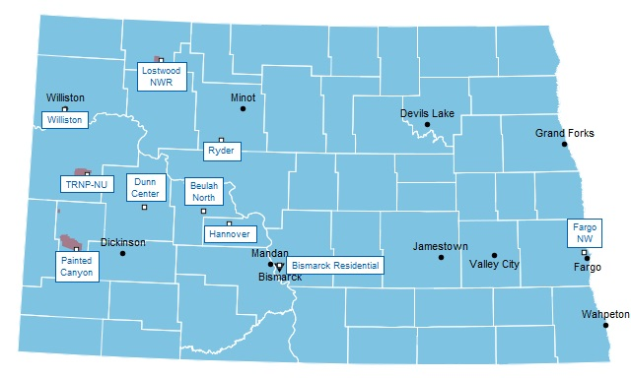

The goal of the VW project is reducing NOx emissions and focusing those reductions on areas that are most impacted by the pollutant. As stated above, North Dakota is in compliance will all National Ambient Air Quality Standards. Neither the State nor Federal NO2 standards of 100 ppb (1-hour) or 53 ppb (annual) are exceeded at any of the North Dakota monitoring sites. In 2016, the maximum concentrations were as follows: three-year average of the 98th percentile 1-hour average concentrations: 33 ppb; annual average: 4.91 ppb. The graphs below depict the 2016 NO2 ambient monitoring summary data for North Dakota.

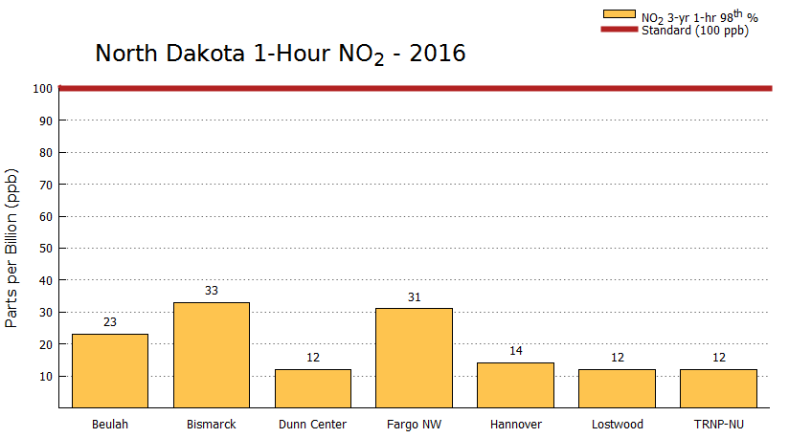

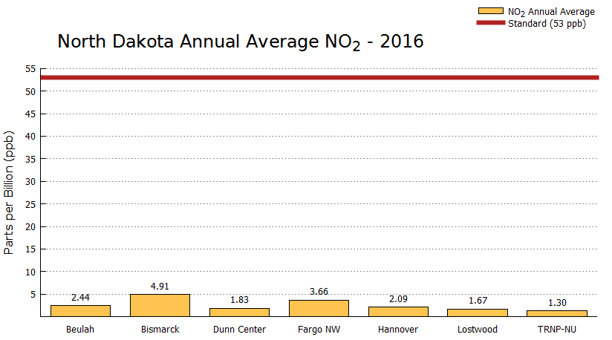

* Vehicle Emissions Data

North Dakota does not have a vehicle emissions testing program. Therefore, data that could potentially be used to focus on specific locations of higher NOx emissions from this source type is not available.

* Conclusion

Since North Dakota is in compliance with the National Ambient Air Quality Standards for NO2 (North Dakota levels are less than half the allowable standards), and a vehicle emissions testing program doesn’t exist to provide additional data, it may be concluded that no areas of North Dakota receive a disproportionate amount of air pollution. Since a wide range of eligible mitigation projects are possible under this settlement, and no data appears to direct the funds to be used in specific locations in the state, the NDDEQ is currently unable to site locations, or specific percentages of funding that each eligible mitigation action category will be allotted.

The NDDEQ utilizes a competitive approach in selecting projects to be funded. The NDDEQ solicits project proposals on an annual basis and formulates a process to evaluate each proposal in terms of the goals and requirements of the settlement. The projects to be considered must fall into one of the eligible mitigation action project categories and are evaluated based upon a scoring and ranking system. Several NDDEQ staff and/or additional designated personnel are involved with evaluating the proposals in a team manner.

Funding priorities are subject to change based upon public input, new or revised air quality information or designations, and other factors that may arise during the lifetime of the project.

**Measuring Emission Reductions and Environmental Benefits**

The primary goal of the environmental mitigation trust fund is to complete projects that reduce NOx emissions. There are several emission calculators available that can calculate emission reductions in a variety of means for various types of projects. However, the NDDEQ anticipates continuing to utilize the U.S. EPA’s Diesel Emission Quantifier (DEQ) for this project. The DEQ is currently utilized by the NDDEQ to complete similar calculations for its State Clean Diesel Grant (DERA). The DEQ is easy to use and focuses on calculating emission reductions from the repower or replacement of medium and heavy-duty diesel engines. In addition to NOx reductions, several other pollutant reductions are expected following the completion of the eligible mitigation actions. These can also be quantified using the DEQ.

**Additional Beneficiary Responsibilities**

1. Beneficiaries may submit requests for eligible mitigation action funding at any time. Each request for funding must be submitted to the Trustee in electronic and hard copy format, and include the following information:

a. An explanation of how the funding request fits into the Beneficiary’s mitigation plan.

b. A detailed description of the proposed eligible mitigation action, including its community and air quality benefits.

c. An estimate of the NOx reductions anticipated as a result of the proposed eligible mitigation action.

d. A project management plan for the proposed eligible mitigation action, including a detailed budget and an implementation and expenditure timeline.

e. A certification that all vendors were or will be selected in accordance with applicable state public contracting laws.

f. For each proposed expenditure exceeding $25,000, detailed cost estimates from selected or potential vendors.

g. A detailed description of how the Beneficiary will oversee the proposed eligible mitigation action, including but not limited to:

1. Identification of the specific governmental entity responsible for reviewing and auditing expenditures of eligible mitigation action funds to ensure compliance with applicable law.

2. A commitment by the Beneficiary to maintain and make publicly available all documentation submitted in support of the funding request and all records supporting all expenditures of eligible mitigation action funds; subject to applicable laws governing the publication of confidential business information and personally identifiable information, together with an explanation of the procedures by which the Beneficiary shall make such documentation publicly available.

h. A description of any cost share requirement to be placed upon the owner of each NOx source proposed to be mitigated.

i. A description of how the Beneficiary complied with subparagraph 4.2.8.

j. A description of how the eligible mitigation action mitigates the impacts of NOx emissions on communities that have historically borne a disproportionate share of the adverse impacts of such emissions.

k. A detailed plan for reporting on eligible mitigation action implementation.

Since the NDDEQ is required to provide this information to the Trustee to receive mitigation trust funds, some or most of this information is requested from interested eligible entities through project proposal submittals, or upon completion of the eligible mitigation action.

2. For each eligible mitigation action, no later than six months after receiving its first disbursement of Trust assets, and thereafter no later than January 1 and July 1 of each year, the Beneficiary shall submit to the Trustee, a semiannual report describing the progress in implementing each eligible mitigation action during the six-month period leading up to the reporting date (including a summary of all costs expended on projects through the reporting date).

3. The Beneficiary shall make information regarding the environmental mitigation trust fund publicly available through websites or other appropriate means.

**Public Information and Input**

This section describes the processes the NDDEQ uses to provide information to the public on the Volkswagen Settlement, as well as the opportunities to provide comments on the development and/or revisions of the mitigation plan.

Information regarding the Volkswagen Settlement is posted at the NDDEQ’s website at <https://deq.nd.gov/AQ/planning/VW.aspx>.

In March 2017, a 30-day public comment period was held for the development of the mitigation plan. The public was asked to provide input on the content of the plan including the inclusion of eligible mitigation actions as well as any other information that could potentially benefit the public. Sixteen commenters provided input during the comment period. The comments were rather wide-ranging and did not appear to focus the development of the plan on certain geographic locations in the state, or certain eligible project categories.

A second public comment period was held July 17, 2018 to August 31, 2018 to help finalize the mitigation plan. Eighteen comments were received. The comments generally offered support for an eligible mitigation action proposed for funding in this plan. A small number of the comments were technical in nature and have been incorporated into this plan.

Two public information meetings were conducted to provide additional opportunities for public input on the development of North Dakota’s initial mitigation plan. Meetings were held in Bismarck and Fargo. The locations, dates and times were made publicly available prior to the meetings.

This, or subsequent mitigation plans will be posted on the website above. Any other revisions will be accompanied by public comment periods and posted on the website as well. The NDDEQ will consider all comments received, review any new or revised settlement requirements, and make necessary revisions to the current, or any future mitigation plans as needed.

**Definitions**

Airport Ground Support Equipment - vehicles and equipment used at an airport to service aircraft between flights.

All-electric - powered exclusively by electricity provided by a battery, fuel cell, or the grid.

Alternate Fueled - an engine, or a vehicle or piece of equipment which is powered by an engine, which uses a fuel different from or in addition to gasoline fuel or diesel fuel (e.g., CNG, propane, diesel-electric Hybrid).

Beneficiary – entity designated by a State’s Governor to administer the Appendix D, Environmental Mitigation Trust of the Volkswagen Partial Consent Decree; the North Dakota Department of Environmental Quality for the state of North Dakota.

CARB – California Air Resources Board.

CFR – Code of Federal Regulations.

CNG – compressed natural gas.

Drayage truck - trucks hauling cargo to and from ports and intermodal rail yards.

Forklift – non-road equipment used to lift and move materials short distances; generally, includes tines to lift objects, and includes reach stackers, side loaders, and top loaders.

Freight Switcher - a locomotive that moves rail cars around a rail yard as compared to a line-haul engine that move freight long distances.

Generator Set - a switcher locomotive equipped with multiple engines that can turn off one or more engines to reduce emissions and save fuel depending on the load it is moving.

Government - a State or local government agency (including a school district, municipality, city, county, special district, transit district, joint powers authority, or port authority, owning fleets purchased with government funds).

Repower - to replace an existing engine with a newer, cleaner engine or power source that is certified by EPA and, if applicable, CARB, to meet a more stringent set of engine emission standards. Repower includes, but is not limited to, diesel engine replacement with an engine certified for use with diesel or a clean alternate fuel, diesel engine replacement with an electric power source (grid, battery), diesel engine replacement with a fuel cell, diesel engine replacement with an electric generator(s) (genset), diesel engine upgrades in Ferries/Tugs with an EPA Certified Remanufacture System, and/or diesel engine upgrades in Ferries/Tugs with an EPA Verified Engine Upgrade. All-electric and fuel cell repowers do not require EPA or CARB certification.

Scrapped - to render inoperable and available for recycle, and, at a minimum, to specifically cut a 3-inch hole in the engine block for all engines. If any eligible vehicle will be replaced as part of an eligible project, “scrapped” shall also include the disabling of the chassis by cutting the vehicle’s frame rails completely in half.

School Bus - a Class 4-8 bus sold or introduced into interstate commerce for purposes that include carrying students to and from school or related events. May be Type A-D.

Tier 0, 1, 2, 3, 4 - corresponding EPA engine emission classifications for non-road, locomotive and marine engines.

Trustee – firm or group that administers the Appendix D, Environmental Mitigation Trust of the Volkswagen Partial Consent Decree. The powers and duties of the Trustee are outlined in Section 3.1 of Appendix D.

Zero Emission Vehicle (ZEV) - a vehicle that produces no emissions from the on-board source of power (e.g., All-Electric or hydrogen fuel cell vehicles).