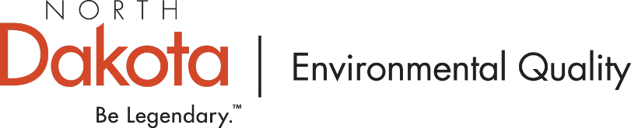

**NEWS** | **FOR IMMEDIATE RELEASE** | June 10, 2025

Department of Environmental Quality urges caution during smoky conditions

BISMARCK, N.D. – The North Dakota Department of Environmental Quality is actively monitoring Canadian wildfires that with current weather conditions are sending smoke into North Dakota. Residents across the state may continue to experience wildfire smoke affecting air quality over the next few days. Environmental Quality advises residents, especially those with respiratory conditions, to consider limiting prolonged outdoor activities when smoky conditions exist at their location.

Environmental Quality closely monitors its air sampling network across the state, so the public is informed and able to take any necessary precautions. Residents are encouraged to use the [AirNow.gov](https://www.airnow.gov/) website and mobile app to access the current air quality conditions.

Environmental Quality advises everyone to use common sense when wildfire smoke adversely impacts air quality. What you should do depends on the air quality index and your personal health status. When air quality is in the “unhealthy for sensitive groups” to “unhealthy” range, people who are in sensitive groups (including those with respiratory conditions, the elderly and young children) may experience health effects during outdoor activities. To decrease the potential for health issues, sensitive groups of people should limit prolonged or strenuous outdoor activity. People reacting to smoke to the extent that it affects breathing should seek immediate help from a medical provider.

**If you see or smell smoke, ways to protect your health include:**

* Stay indoors with windows and doors closed.
* Limit or avoid strenuous outdoor activity.
* Set air conditioners or vehicle vents to recirculate indoor air.

What you should do depends on the air quality index and your personal health status. Due to the active wildfires and changing wind patterns, air quality can be variable and unpredictable. Air quality may improve at times or get worse very quickly.

For up-to-date information on the region’s air quality, fires, and smoke plumes visit [fire.airnow.gov](https://fire.airnow.gov/) which also provides respiratory protection tips during a smoke event. The AirNow mobile phone app, and many other weather apps, also include air quality information.

**Understanding the Air Quality Index (AQI)**

The AQI is a color-coded tool that helps you understand what the air quality means for your health. Here's a quick reference:

# Resources

# Air Quality Index & Map: [www.airnow.gov](https://www.airnow.gov)

# Real-time Fire and Smoke Map: [fire.airnow.gov](https://fire.airnow.gov)

# North Dakota Air Monitoring Data: [deq.nd.gov/AQ/monitoring](https://deq.nd.gov/AQ/monitoring/)

# National Weather Forecast for ND: [graphical.weather.gov – ND](https://graphical.weather.gov/sectors/northdakota.php)

# Wildfire Smoke Forecasts: [firesmoke.ca](https://firesmoke.ca/forecasts/current/)

# *Questions about the continuation of outdoor activities, events, and sports practice should be directed to the local administrators in charge.*

# For more information, contact:

Ryan Mills

Division of Air Quality

PHONE: 701-328-5188 | EMAIL: [rmills@nd.gov](mailto:rmills@nd.gov) | [www.deq.nd.gov](http://www.deq.nd.gov/)