Schafer, Jacob R.
NORTH DAKOTA DEPARTMENT OF ENVIRONMENTAL QUALITY 918 E Divide Ave Bismarck
ND backflow prevention and Cross Connection control guidance

TABLE OF CONTENTS

Part 1. Introduction 1
1.1 Overview 1
1.2 Background 2
1.3 Purpose of this Guidance Document 2
Part 2. Department Notification 2
2.1 Reportable Backflow Events 2
2.2 Reportable Regulatory Requirements 3
2.3 Public Notice Requirements 3
Part 3. Backflow Prevention and Cross-connection Control Program 3
3.1 Legal Authority 4
3.2 Prohibition of Installing or Permitting Cross Connections 4
3.3 Identification of Cross Connections 4
3.4 Survey Process and Documentation 6
3.4.1 Single-Family-Residential Connections 6
3.4.2 Cross Connections Not Identified 7
3.5 Identified Cross Connections 7
3.6 Assembly and Method Selection 7
3.7 Tracking, Testing, and Maintenance 9
3.7.1 Failed Assembly or Inadequate Method 9
3.8 Certified Tester 9
Part 4. Backflow Prevention and Cross-connection Control Annual Report 10
Part 5. Standards for Construction and Installation 12
5.1 Site-specific Deviation Criteria Development 12
APPENDIX A – BPCCC Program Template 13
APPENDIX B – Sample Ordinance 13
APPENDIX C – Cross-connection Control Extension 13
APPENDIX D – BPCCC Annual Report & Tracking Spreadsheet 13
APPENDIX E - BPCCC Survey and Questionnaires 13
E.1 Sample Cross Connection Identification Survey Form 13
E.2 Sample Cross Connection Identification Questionnaire and Letter to Consumer 13
E.3 Sample Cross Connection Identification Survey for Water Supply Systems 13
E.4 Sample Cross Connection Identification Survey for Waterworks 13
APPENDIX G - Public Water System Program and Report Template 13
APPENDIX H - Non-community Public Water System Program and Report Template 13
APPENDIX I - Example Assembly and Method Test Reports 13
APPENDIX J - Backflow Prevention Devices, Assemblies and Methods 13

- Introduction

1.1 Overview
North Dakota Administrative code 33.1-17-01-19. (Protection of public water systems)

Generally, a Backflow Prevention and Cross-Connection Control (BPCCC) program, requires that water suppliers do all the following:

• Develop and implement a written BPCCC program;
• Notify the Department of any suspected or confirmed backflow events;
• Do not install cross connections at its facilities or throughout the distribution system;
• Do not allow any cross connections to continue to exist once discovered;
• Control the installation of new uncontrolled cross connections;
• Survey all non-single-family-residential connections for cross connections or control non-surveyed non-single-family-residential connections with the most protective backflow prevention assembly or backflow prevention method;
• Protect against any identified cross connection in a manner that prevents backflow through the cross connection into the distribution system or if applicable the water supply system;
• Document annual backflow prevention assembly testing;
• Document annual backflow prevention method inspections and/or annual surveys;
• Ensure that all failed assemblies and inadequate methods are repaired; and,
• Keep records and develop an annual report.

The Department reviews a public water system’s backflow prevention and cross-connection control implementation procedures, methods, and records during sanitary surveys to determine whether the water supplier is compliant with 33.1-17-01-19. Inadequate protection, record keeping, reporting, operational, maintenance or other practices may be identified as a defect, significant deficiency and/or violation that must be corrected for water suppliers to remain in compliance with 33.1-17-01-19.

The Department has developed a Safe Drinking Water Policy titled “Backflow Prevention and Cross-Connection Control Implementation Policy” to provide additional information to assist water suppliers. It further explains how the Department evaluates whether a water supplier is meeting the performance requirements of the BPCCC policy. This policy establishes and clarifies certain terminology used in the BPCCC policy as relating to:

• Permitting an Uncontrolled Cross Connection;
• Ensuring that Activities are Completed – Implementing Legal Authority;
• Appropriate Assembly or Method for an Identified Contaminant;
• Unacceptable Health and/or Safety Risk;
• Site-specific Deviation Criteria;
• Most Protective Backflow Prevention Assembly or Method;
• Survey Process Documentation;
• Public Water System’s Water Supply System Cross Connections Program; and,
• Active Date.

1.2 Background
The North Dakota Statutes require that water suppliers provide cross-connection control within their own water supply systems. It is required that the cross connections be controlled. Commercial and residential facilities are required to protect the potable water supply in accordance with the local jurisdictional plumbing code. If there is not a local code the North Dakota Plumbing Code applies.

1.3 Purpose of this Guidance Document
This guidance is designed to help water suppliers comply with the BPCCC policy that the Department may evaluate at will and during sanitary surveys. Therefore, the purpose of this guidance document is to:
• Assist water suppliers in developing and implementing an adequate BPCCC program;
• Provide templates for BPCCC policy requirements; and,
• Provide a common reference for water suppliers and Department staff.

This guidance document is not a regulation, is not a policy, and does not preclude other means for water suppliers to demonstrate that they comply with 33-17-01-19. However, the methods described in this document are based on widely accepted industry standards, the North Dakota Plumbing Code, EPA guidance and previously published Department guidance. This guidance addresses all water suppliers that operate regulated public water systems. When the term “must” is used in this document it means that the action is required by 33.1-17-01-19. Additionally, this guidance does not address unregulated treatment at private buildings or treatment for aesthetic concerns common to many plumbing arrangements found in North Dakota. This document will be updated as needed to include the most relevant and updated information available by the Department and the latest version can be found at https://deq.nd.gov/MF/BPCCC/.

- Department Notification

2.1 Reportable Backflow Events
All water systems experience conditions that could allow for the unintended reverse flow of fluids. This is known as a backflow event. Backflow through a cross connection can pose a risk to a public water system and its users. These risks may be acute or long term and could cause an immediate health risk to the public. If a backflow event contaminates the public water system, the North Dakota Department of Environmental Quality must be notified 40CFR141.202(a)(9).

2.2 When and what to report?
If a supplier learns of a suspected or confirmed backflow contamination event, the supplier must notify and consult with the Department on any appropriate corrective measures no later than 24 hours after learning of the backflow contamination event. In the interest of public health, the Department encourages anyone aware of a backflow event, which may have contaminated a public water system through a cross connection, to call the Department as soon as possible after necessary emergency response calls have been made.

When reporting the event, please have available as much of the following information as
possible:

• Date and time of event;
• Location of event;
• Type of threat or incident (bacteriological chemical, radiological, physical, etc.);
• Public Water System Name and Identification Number;
• Water supplier contact name and phone number;
• Method of discovery (consumer complaint, witness, perpetrator, employee report);
• Response actions taken (water quality parameter testing, isolation of affected water);
• Recovery actions taken;
• Notifications made (customers, law enforcement, news media, etc.);
• Assessment of threat, if possible.

Once the Department has gathered the necessary information, the Department will provide assistance to ensure the safety of the public and the integrity of the public water system.

2.3 Public Notice
Suppliers will distribute Tier 2 public notice as specified in any instance the supplier becomes aware of any backflow prevention and cross-connection control treatment technique violation. Tier 3 public notice is required for any other instance the supplier becomes aware of any backflow prevention and cross-connection control violation. Please contact the North Dakota Department of Environmental Quality with any questions regarding any public notice issues. Department assigned contacts can be found online at https://deq.nd.gov/MF/BPCCC/

- Backflow Prevention and Cross-connection Control Program

Protection of public health from cross connections is best achieved through a properly developed, administered, and implemented Backflow Prevention and Cross-connection Control program. The development of a written BPCCC program will be essential. The written BPCCC program should clearly outline all procedures, duties and responsibilities associated with the implementation of the BPCCC program.

The BPCCC program will need to include and specify information regarding how the supplier identifies cross connections, performs surveys, and controls identified cross connections. The BPCCC program must also address how the supplier requires that backflow prevention assemblies and methods be tested and inspected annually, how the supplier will track the installation, maintenance, and testing of assemblies and methods and how the supplier will ensure that assemblies are tested by a Certified Cross-Connection control Technician, as required in the Uniform Plumbing Code (603.2 Approval of Devices and Assemblies). Many of these program components can be addressed through the establishment of legal authority.

Appendix A contains a link to a Department template for a written BPCCC Program. For suppliers that operate a non-community public water system, the Department has developed a simpler written program which includes the annual compliance report. The combined BPCCC non-community written program and report can be found in Appendix H. Water suppliers should be prepared for a program review during each sanitary survey.

3.1 Legal Authority
Generally, community public water systems administer three types of BPCCC programs. The most common forms of observed programs are based on one of the following: local government ordinances, user agreements or full public water system responsibility. An example ordinance can be found at https://deq.nd.gov/MF/BPCCC/

Generally, non-community public water systems own their water supply system. When that is the case, the responsibility falls on the water supplier to control identified cross connections. If the supplier serves water to customers through a service connection, the water supplier must implement a user agreement between the customers or take on full public water system responsibility to ensure that cross connections are controlled.

The supplier must have a legally enforceable mechanism that implements its BPCCC program. The Department recommends that the legally enforceable mechanisms include specific provisions identifying customer requirements and responsibilities, along with the associated remedies that the water supplier may utilize for failure of customer(s) to comply.

3.2 Prohibition of Installing or Permitting Cross Connections
North Dakota Statute 33.1-17-01-19. (Protection of public water systems)

- Cross connection control.

(a). Cross connections are prohibited except when and where, as approved by the authority having jurisdiction, suitable protective devices are installed, tested, and maintained to ensure proper operation on a continuing basis.
(b). A system shall be designed, installed, and maintained in such a manner as to prevent non potable liquids, solids, or gases from being introduced into the water through cross connections or any other piping connections to the system.

- Interconnections.

(a). Interconnections between two or more systems shall be permitted only with the written approval of the Department.
(b). Interconnections between a nonpublic and public water system shall not be permitted unless specifically approved in writing by the Department.

3.3 Identification of Cross Connections
Suppliers must survey all non-single-family-residential connections to the public water system to determine if actual or potential cross connection exists. The supplier must also survey all connections within the supplier’s waterworks to determine if there are any cross connections present which could contaminate the public water systems or the facility’s water supply system. Acceptable survey process documentation should include how the supplier will select service connections that need a survey. The following: 1. Usage type (commercial, industrial, or multi-family); 2. New or newly acquired connections; and 3. Questionnaire results.

Single-family means:
• A single dwelling which is occupied by a single family and is supplied by a separate
service line;
• A single dwelling comprised of multiple living units where each living unit is supplied
by a separate service line.
• If a water supplier has ownership and maintenance responsibilities of a service line up
to a point of single-connections such connections may be considered a single-family-
residential connection even if this connection is to a multi-family dwelling unit.

Multi Family Connection
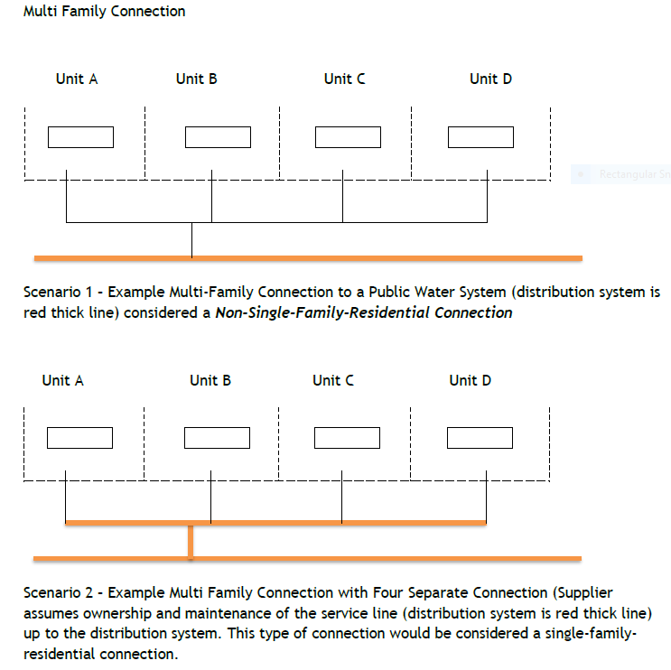

3.4 Survey Process and Documentation
Once the supplier has identified the total number of non-single-family residential connections, the supplier must survey the connections to identify cross connections. The supplier must document the process for conducting surveys. Surveys can be performed onsite by a person designated by public water system or can be a questionnaire type. The supplier’s survey process should identify potential service connections and uses that when identified may trigger cross-connection control requirements. The supplier’s process should address how the supplier will select individuals to perform the survey including experience and/or training or certification qualifications to perform a survey. Additionally, the supplier must survey any waterworks and the water supply systems associated with those facilities for cross
connections.

Should the supplier use questionnaires, various methods may be used to distribute the questionnaires such as email surveys, web-based surveys, written surveys, or telephone surveys. Questionnaires should provide examples of common cross connections to the customer who completes the survey. Questionnaires should ask that the property-owner indicate the information provided is accurate to the best of their knowledge. If the supplier does not receive a response to a questionnaire or the results are inconclusive, the supplier is required to perform an onsite survey for cross connections or control the connection with the most protective backflow prevention assembly or method.

The Department has developed several example survey questionnaires that can be found at
https://deq.nd.gov/MF/BPCCC/

It is important that newly constructed and renovated buildings are constructed in accordance
with the local plumbing code. The code is intended to protect the internal potable water system and its occupants from contamination that can be introduced via restrooms, kitchens, boilers, irrigation, HVAC systems, etc. It is equally important that the water supplier protect their distribution system from contamination that can be introduced via car washes, auxiliary water sources, fire suppression systems, irrigation and many other sources. Water suppliers need to perform cross connection identification surveys to identify potential cross connections within their distribution system.

Suppliers may choose not to perform surveys of non-single-family-residential connections if the supplier controls that connection with the most protective backflow prevention assembly or backflow prevention method. The following are acceptable “most protective backflow prevention assemblies or methods”:
- Method - air gap installed in accordance with standard AMSE A112.1.2.
- Assembly - reduced pressure zone backflow prevention assembly.

3.4.1 Single-Family-Residential Connections
The supplier is not required to perform surveys at single-family-residential-service connections. However, if the supplier becomes aware of a single-family-residential connection to the public water system that is a cross connection, the supplier must control the cross connection.

If the supplier’s public water system consists only of single-family-residential-service connections, the public water system does not have to perform surveys at those service connections, however, the supplier must survey its waterworks and identify if there are any direct connections to the public water system’s distribution system such as irrigation systems, maintenance shops, fire suppression systems, agricultural uses, water fill stations or other hazards.

3.4.2 Cross Connections Not Identified
If the survey process identifies no cross connection, the supplier must document the results of the surveys. The supplier is still required to have a written cross connection control program. The written BPCCC program should mention how the supplier will continue to evaluate new service connections and changes in use for potential cross connections.

3.5 Identified Cross Connections
Once a supplier has learned of a cross connection the supplier must act, based on the specific site conditions.

If the supplier learns of an identified cross connection and suspects or confirms that backflow contamination has occurred, the supplier must notify and consult with the Department on any appropriate corrective measures no later than 24 hours after learning of the backflow contamination event. Part 2.1 of this document provides guidance for reporting contamination events to the Department.

If the supplier believes that an identified cross connection could present an immediate health risk to the public based on the site’s hydraulic conditions and the acute toxicity of the identified risk, the Department requests notification for further evaluation to determine if alternative action is necessary based on threat to public health. Such action could be an expedited schedule to remove the cross connection or the Department or supplier could issue a bottle water advisory for the impacted area.

If the supplier discovers an uncontrolled cross connection and believes that a backflow contamination event has not occurred, the supplier must: 1) determine the type of backflow prevention assembly or backflow prevention method needed to control the cross connection, 2) install and maintain or require the customer to install and maintain a backflow prevention assembly or backflow prevention method at the uncontrolled cross connection, suspend service to the customer, or remove the cross connection, no later than 60 days after its discovery.

If the supplier becomes aware of a single-family-residential connection to the public water system that is a cross connection, the supplier must control the cross connection.

If the supplier is unable to meet the 60-day deadline, the supplier must consult with the Department and the Department may approve an alternative schedule.

3.6 Assembly and Method Selection
The supplier must describe the process used to select a backflow prevention assembly or backflow prevention method to control a cross connection in the written BPCCC program. Suppliers should include in the written BPCCC program guidelines and criteria used to select the type of backflow prevention assembly or method used to control the identified cross connections. Guidelines and criteria should address examples of cross connections throughout the water system’s distribution system along with the corresponding appropriate backflow prevention assembly and or backflow prevention method used to control the identified cross connection. Part 4.2 provides various examples of backflow prevention assemblies and methods and when the use of such assemblies and methods may be appropriate. Many water systems will choose to control all cross connections with the most protective backflow prevention assembly or method and will not have to develop guidelines or criteria. The rest of the water systems will need to identify the selected industry standards that are used to make control determinations.

“CONTAINMENT” means the installation of a backflow prevention assembly or a backflow prevention method at any connection to the public water system that supplies an auxiliary water system, location, facility, or area such that backflow from a cross connection into the public water system is prevented.

“CONTAINMENT BY ISOLATION” means the installation of backflow prevention assemblies or backflow prevention methods at all cross connections identified within a customer’s water system such that backflow from a cross connection into the public water system is prevented.

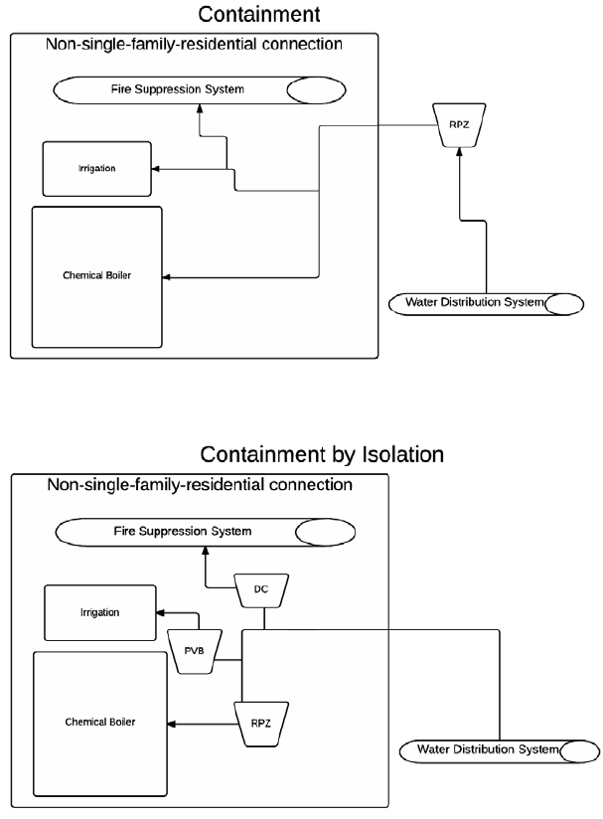

3.7 Tracking, Testing, and Maintenance
Suppliers must specify the process that the water system will use to require the installation, maintenance, testing, and inspection of all backflow prevention assemblies and backflow prevention methods used to control cross connections. Generally, this is specified in one of the following: local government ordinances, user agreements or the public water system assumes full responsibility. Suppliers must also specify the tracking mechanism it will use to verify the installation, maintenance, testing, and inspection of all backflow prevention assemblies and backflow prevention methods used to control cross connections.

Appropriate tracking mechanisms will vary depending on the number of identified cross connections. If a water system performs a survey and no cross connections are identified then there will be no further tracking requirements; however, the supplier’s survey process will need to include an evaluation process which will capture potential changes in customers at surveyed service connections. New customers may create new cross connections which are required to be controlled. If the supplier identifies any cross connections that require control, the supplier must develop an appropriate tracking mechanism for the installation, testing and maintenance of those assemblies and methods. Tracking methods may vary from a simple list, to a more complicated spreadsheet or tracking software specifically dedicated to control of cross connections. The Department has developed a sample tracking spreadsheet that can be found in Appendix D. This tracking sheet can be used as a water system’s annual report.

A good tracking mechanism will be able to keep track of the location of the cross connection (address and a description of the location of the assembly or method), facility contact and phone number, the cross-connection type, the assembly or method used to control the cross connection, when available the initial discovered date, date assembly tested and result (pass/fail) for the preceding three-year period, active date and any other notes that may be useful to the supplier such as installation issues or pass/fail history.

3.7.1 Failed Assembly or Inadequate Method
If the supplier is notified of a failed assembly or an inadequate method the supplier must ensure that the backflow prevention assembly that produced the failed test is repaired or replaced and tested, or that the inadequate method is corrected, or service is suspended to the customer, or the cross connection is removed.

The supplier may receive a Department-approved alternative compliance schedule for failed assemblies or inadequate methods that have not been repaired/corrected within 60 days. Department approval of an alternative compliance schedule means either an email or other written communication from the Department. The Department has provided APPENDIX C – Cross-connection Control Extension Application for such requests.

3.8 Certified Tester
The process the supplier will use to ensure backflow prevention assemblies are tested by a Certified Cross-Connection Control Technician. The Department will determine the adequacy of a supplier’s process to ensure that testing has been completed by a certified professional. Typically, the supplier complies with this section if the supplier does the following:

i. The supplier has a documented process in place where the supplier receives a test report directly from the Certified Cross-Connection Control Technician or their associated company.

ii. To be considered adequate, test reports used to document compliance must include all the following:

Assembly or method information:
a. Assembly or method type;
b. Assembly or method location;
c. Assembly make, model and serial number;
d. Assembly size;
e. Test date; and,
f. Test result (pass/fail),
g. Test kit make, model, serial number and calibration date.

Certified Cross-Connection Control Technician information
a. Certified Cross-Connection Control Technician certification agency;
b. Certification number;
c. Certification expiration date or statement that certification is current; and,
d. As an alternative to a-c, suppliers may provide documentation of an
alternative validation process such as electronic login to reporting software
where only current, certified cross-connection control technicians (or their
companies) are given a login.

iii. APPENDIX I provides examples of acceptable test reports.

4. Backflow Prevention and Cross-Connection Control Annual Report
To evaluate compliance with the backflow prevention and cross-connection control requirements and ensure protection of public health from cross connections suppliers must develop a written backflow prevention and cross-connection control annual report. For each calendar year the written BPCCC annual report must be completed by May 1 of the following year. The report will need to be made available to the Department upon request and will be evaluated during sanitary surveys for compliance. A backflow prevention and cross-connection report template can be found in Appendix D. Also, for non-community systems, the combined BPCCC written program and report can be found in Appendix H, and includes:

1. Total number of non-single-family-residential connections to the public water system and connections within the supplier’s waterworks. This is the number of connections that the supplier has identified which will either require a survey or protection. This number should be tabulated once and updated as needed. This number can only increase with new connections to the public water system’s distribution system and can only decrease if connections to the distribution system are reduced. **Note** The supplier is not required to include any non-single-family-residential connections identified after October 31 of the calendar year in the total number of non-single-family-residential connections to the public water system until the following calendar year.

2. Total number of connections surveyed to determine if cross connections are present. If
a supplier chooses to control a connection with the most protective backflow prevention assembly or method for reporting purposes the connection can be considered surveyed and reported as such. This number is a tabulation of all connections surveyed and controlled throughout the years and not the number of connections surveyed that year.
- Survey compliance ratio (SCR). SCR is equal to the total number of connections surveyed divided by the total number of non-single-family-residential connections identified.

Table – I Survey Compliance Ratio
Compliance Date | Compliance Ratio
1st year | Greater than 0.60
2nd year | Greater than 0.70
3rd year | Greater than 0.80
4th year | Greater than 0.90
each year after | 1.0

4. Total number of identified cross connections. If a supplier chooses to control a connection with the most protective backflow prevention assembly or method for reporting purposes the connection can be considered a cross connection and reported as such.

5. Number of uncontrolled cross connections identified during the calendar year.
a. Number of identified uncontrolled cross connections that were controlled within 60 days of discovery.
b. Number of identified uncontrolled cross connections that were not controlled within 60 days of discovery.

6. Number of backflow prevention assemblies installed at cross connections that were
used during the calendar year. This is the number of assemblies installed that protected the public water system from potential contamination via cross connections for the previous calendar year.

7. Number of backflow prevention methods installed at cross connections that were used
during the calendar year. This is the number of methods installed that protected the public water system from potential contamination via cross connections for the previous calendar year.

8. Number of connections where service was suspended as specified in 11.39(3) during the calendar year.

9. Number of backflow prevention assemblies used to control cross connections that were
tested by a Certified Cross Connection Control Technician during the calendar year.

10. Backflow prevention assembly annual testing compliance ratio (ATR). The ATR is equal to the total number of assemblies tested during the previous calendar year divided by the total number of assemblies used to protect the distributions system during the previous calendar year.

Table – II Backflow Prevention Annual Testing Survey Compliance Ratio
Compliance Date | Compliance Ratio
1st year | Greater than 0.50
2nd year | Greater than 0.60
3rd year | Greater than 0.70
4th year | Greater than 0.80
each year after | Greater than 0.90

4.1 Examples of backflow prevention assemblies and methods and when the use of such assemblies can be found in the ND 2018 Plumbing Code, Chapter 6, Water Supply and Distribution, Table 603.2, Backflow Prevention Devices, Assemblies, and Methods http://epubs.iapmo.org/2018/NorthDakota/#p=65

5. Standards for Construction and Installation
Water suppliers are expected to develop methods or adopt standards to ensure that customers install the appropriate level of backflow prevention at service connections using example standards found in Appendix J, in reference to the 2018 ND Plumbing Code.

APPENDIICIES

APPENDIX A – BPCCC Program Template
APPENDIX B – Sample Ordinance
APPENDIX C – Cross-connection Control Extension
APPENDIX D – BPCCC Annual Report & Tracking Spreadsheet
APPENDIX E - BPCCC Survey and Questionnaires
E.1 Sample Cross Connection Identification Survey Form
E.2 Sample Cross Connection Identification Questionnaire and Letter to Consumer
E.3 Sample Cross Connection Identification Survey for Water Supply Systems
E.4 Sample Cross Connection Identification Survey for Waterworks
APPENDIX G - Public Water System Program and Report Template
APPENDIX H - Non-community Public Water System Program and Report Template
APPENDIX I - Example Assembly and Method Test Reports
APPENDIX J - Backflow Prevention Devices, Assemblies and Methods

